Virtual box installation

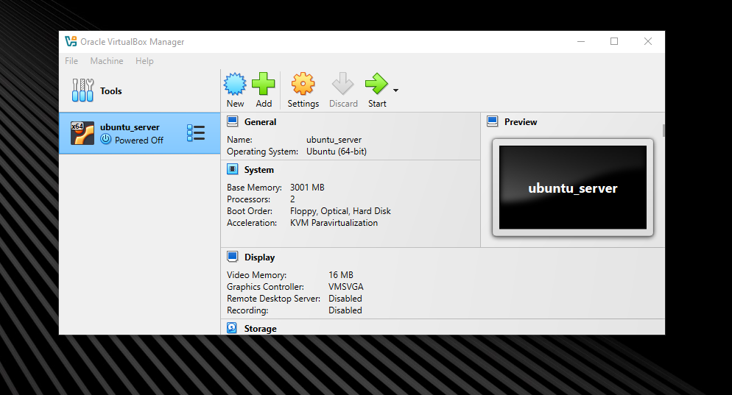

Ubuntu server installation

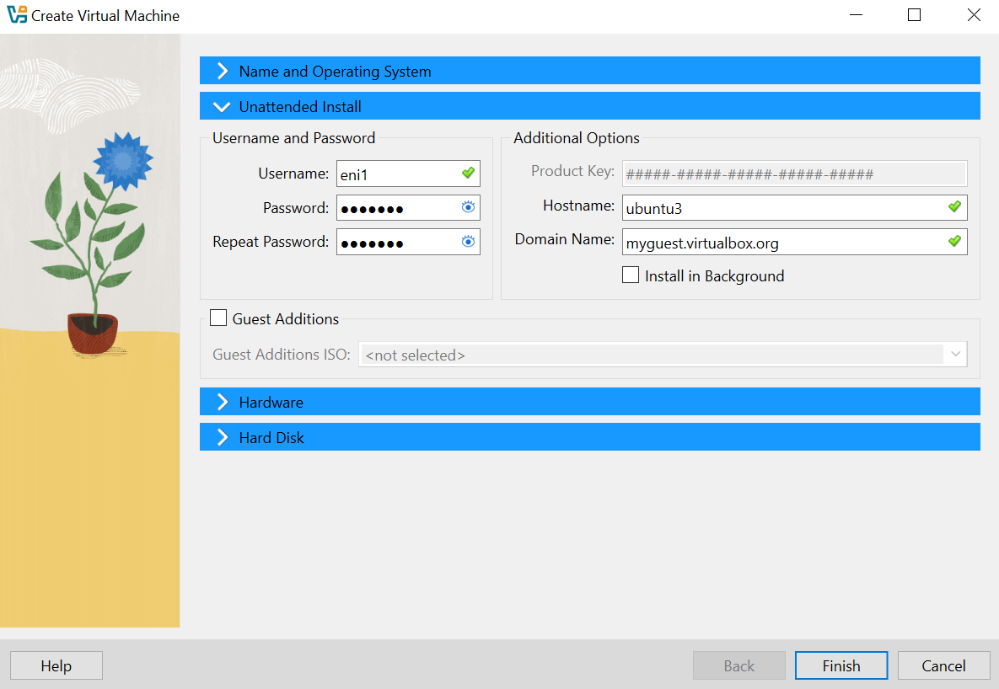

Installing ubuntu desktop on vm

Openssh

Also add the following commands

Sudo systemctl enable ssh

Sudo systemctl start ssh

To check if it works

Connecting via ssh to my vm from command prompt

Web server

Run these commands

sudo apt install apache2

sudo systemctl enable apache2

sudo systemctl start apache2

how to check if it runs

How to access the server

Enter <http://ipaddr>

Configure firewall to allow http/https traffic

sudo ufw allow 'Apache'

# or more specifically:

sudo ufw allow 80/tcp

sudo ufw allow 443/tcp

if you want to access it using https

sudo a2enmod ssl

sudo systemctl restart apache2

sudo a2ensite default-ssl

sudo systemctl reload apache2

ftp server

sudo apt install vsftpd

sudo systemctl enable vsftpd

sudo systemctl start vsftpd

how to configure it



After saving the file execute this command

sudo systemctl restart vsftpd

ftpuser

Bubulinuta1!

Assign user permissions to upload files

sudo mkdir /home/ftpuser/ftp

sudo chown ftpuser:ftpuser /home/ftpuser/ftp

sudo chmod 700 /home/ftpuser/ftp

Dhcp server

sudo apt install isc-dhcp-server

sudo systemctl enable isc-dhcp-server

sudo systemctl start isc-dhcp-server

open the configuration file sudo nano /etc/dhcp/dhcpd.conf

Edit the default configuration for dhcp

sudo nano /etc/default/isc-dhcp-server

The network interface name can be found with ip a command

Dns server

sudo apt install bind9 bind9utils

sudo systemctl enable named

sudo systemctl start named

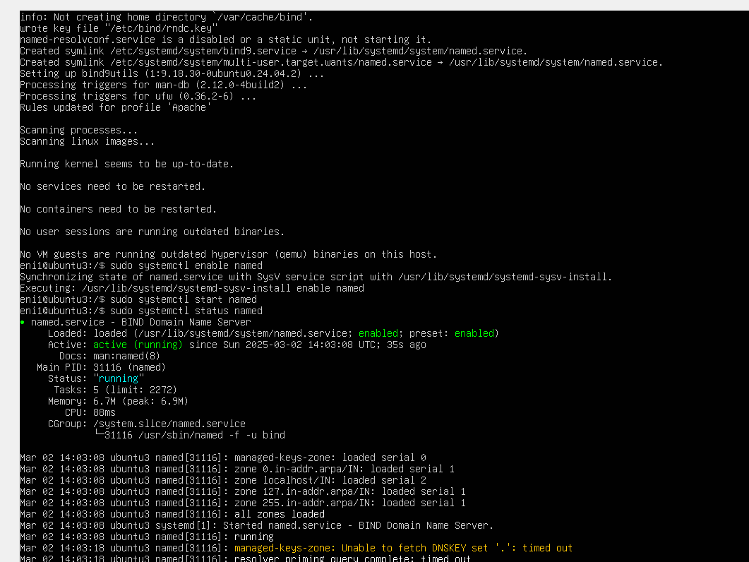

Configuration

sudo nano /etc/bind/named.conf.local

mail server

sudo apt install postfix

sudo systemctl enable postfix

sudo systemctl start postfix

Sudo apt install mailutils

Then I used the command **sudo cat /var/mail/root** tat uses **sudo** to run the

**cat** command with superuser privileges, allowing it to read the contents of

the mail file for the **root** user, located at **/var/mail/root** . This displays the

**root** user's email messages stored on the system directly in the terminal to

see that the email was sent.

Pop3/imap

sudo apt install dovecot-core dovecot-imapd dovecot-pop3d

sudo systemctl enable dovecot

sudo systemctl start dovecot

configuration

sudo nano /etc/dovecot/dovecot.conf

sudo mkdir -p /home/ftpuser/Maildir

sudo chown -R ftpuser:ftpuser /home/ftpuser/Maildir



imap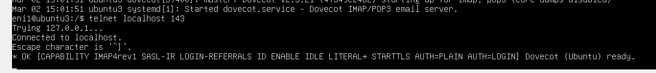

pop3

Pop3s/imaps

sudo apt install dovecot-core dovecot-imapd dovecot-pop3d

squid proxy

sudo apt install squid

sudo systemctl enable squid

sudo systemctl start squid

* Change the configuration file such that Squid will allow clients to connect to it:



Docker

sudo apt install apt-transport-https ca-certificates curl software-properties-common

curl -fsSL https://download.docker.com/linux/ubuntu/gpg | sudo apt-key add -

sudo add-apt-repository "deb [arch=amd64] https://download.docker.com/linux/ubuntu $(lsb_release -cs) stable"

sudo apt update

sudo apt install docker-ce

sudo systemctl enable docker

sudo systemctl start docker

**Administration Tasks**

**Monitor Services Availability**

Monit

sudo apt install monit

sudo systemctl enable monit

sudo systemctl start monit

uncomment this

Monitoring -htop

Performance Testing

sudo apt install stress sysbench

sudo apt install htop iotop

Log analyzer

sudo apt install logwatch goaccess

run this command sudo logwatch --detail high --range yesterday --service all --format text

Backup tasks

**Security Tasks**

**Firewall (UFW - Uncomplicated Firewall)**

sudo apt install ufw

sudo ufw allow ssh

sudo ufw allow http

sudo ufw allow https

sudo ufw enable

Brute Force Detection/Prevention (Fail2ban)

sudo apt install fail2ban

sudo systemctl enable fail2ban

sudo systemctl start fail2ban

